**Fop Lab Home Task 4**

**Name:** Hafiz Mufassir Amjad

**CMS ID:** 456049

**Section:** B

**TASK 1**

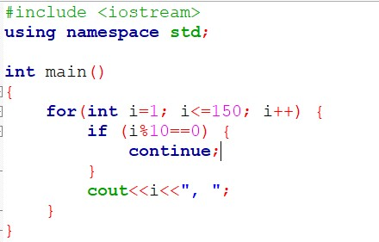

**Output**

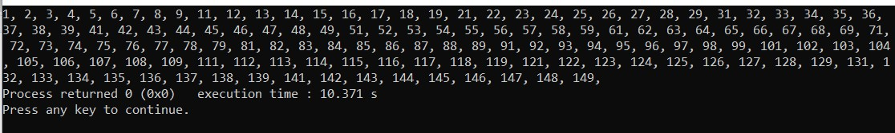

**Explanation**

This code prints numbers from 1 to 150 and skips multiples of 10 using a continue statement. It uses a for loop to iterate over 150 numbers and prints all the numbers except multiples of 10

**TASK 2**

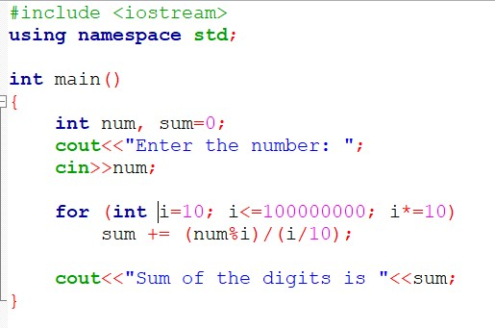

**Output**

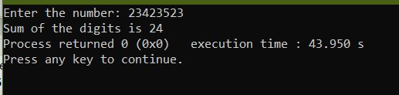

**Explanation**

This code takes an integer as an input from user and sums up all the digits of the number. It gets the digit by removing left side by using modulo operator and by removing right side by using division operator.

**TASK 3**

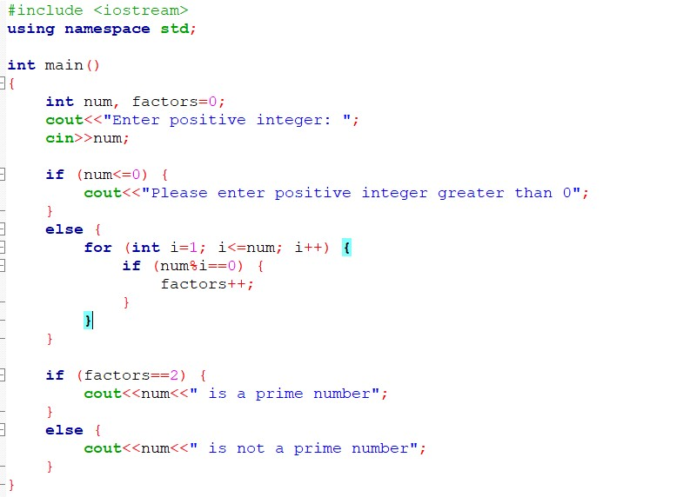

**Output**

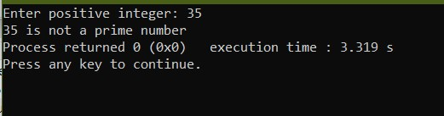

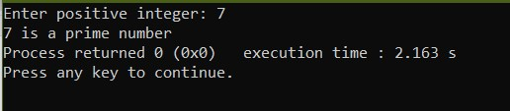

**Explanation**

This code takes an integer from the user and calculates its factors using a for loop. If the number of factors is 2 then it is a prime number, otherwise it is not a prime number.